Link’s quest is taken to a new level, in a brand new show!

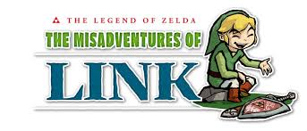

You might have thought that the Legend of Zelda cartoon would be the last time you saw Link in his own show. Nintendo had other plans.

Nintendo released a new show on Nintendo Video on Friday, November 1, centered around Link’s adventures, or I should say his misadventures.

The Legend of Zelda the Misadventures of Link is a series of humorous shorts based around the Legend of Zelda: The Wind Waker HD. It is planned to run into 2014. The first episode has already been released, and can be viewed on the Nintendo 3Ds/3DS XL/ 2DS or through the link listed below.

I personally think that this little spin-off series is a great idea and the final product is amusing and entertaining. Tell us in the comment section below what your thoughts are.

Link to first episode.

Source: zeldainformer ( via Joystiq )

http://www.zeldainformer.com/news/the-misadventures-of-link-now-available-on-nintendo-video

http://www.joystiq.com/2013/10/31/misadventures-of-link-pikmin-and-bravest-warriors-coming-to-nin/

